PROG 102 - PRINCIPLES OF SOFTWARE ENGINEERING

FINAL PROJECT
Software Design for a Digital Public Good
AquaLink Salone
Student Name: GROUP 2 PROJECT BIT1203F Course: PROG 102 - Principles of Software Engineering
Examiner: Santigie Foday Kamara Submission Deadline: Week 11

Project Title
AquaLink Salone: A Digital Public Good System for Community Water Safety Reporting and Repair Coordination
This project proposes an open, reusable software design for improving access to safe public water. It helps residents report unsafe or broken water points, supports volunteers in verifying reports, allows local officers to coordinate repairs, and publishes simple public data for accountability.

Problem Statement
In many communities, public taps, wells and hand pumps become unsafe or unusable before the responsible authorities receive clear information. Residents may continue using contaminated water because they do not know which nearby water point is safe, while officers lack a structured way to prioritize repairs. AquaLink Salone addresses this gap through a community-first reporting platform that combines mobile reporting, field verification, GIS mapping, repair tracking and SMS alerts.

SDG Relevance
The system aligns mainly with United Nations Sustainable Development Goal 6: Clean Water and Sanitation. It also supports SDG 3 by reducing water-related health risks and SDG 11 by strengthening community resilience. Its real-world value is that it turns water safety problems into visible, trackable cases with response ownership and public feedback.

Selected SDLC Model
The project will use the Agile SDLC model because community water problems change quickly and users need to see early prototypes before the full system is implemented. Agile supports short iterations, regular feedback from residents and officers, and continuous improvement of the interface.

SDLC Phases for the System
Phase | What happens in AquaLink Salone
Planning | Identify target communities, SDG 6 goals,  stakeholders, risks, scope, timeline and success indicators.
Requirements Analysis | Collect user stories from residents, volunteers, water officers and NGOs. Define reporting, verification,  mapping, alert and dashboard requirements.
Design | Create architecture, database model, UML diagrams, UI style guide and Figma screens.
Development | Build mobile screens, web dashboard, API services,  database tables, authentication, GIS features and notification services.
Testing | Test usability, report submission, data validation, role permissions, alert delivery, and dashboard accuracy.
Deployment | Publish the app, host the API and database, connect  SMS gateway, train community volunteers and launch a pilot ward.
Maintenance | Monitor feedback, fix defects, improve performance, add languages and update the open data dashboard.

System Architecture Design
The system uses a layered architecture. User interfaces communicate with an API gateway, which routes requests to service modules. The service layer stores information in a PostgreSQL and GIS-enabled database, then sends alerts through SMS and email integrations. This structure makes the system easier to maintain, test and extend.

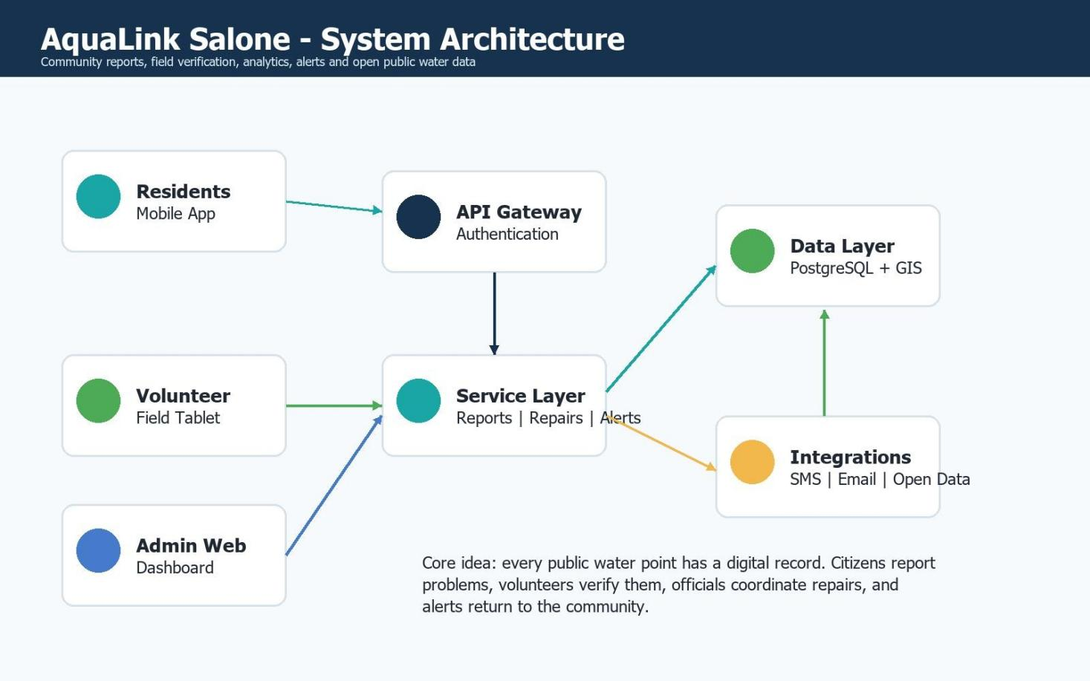

Component | Responsibility
Mobile App | Allows residents to register, view water status, report problems and receive alerts.
Volunteer Tablet View | Supports field verification, photo evidence, checklist completion and GPS confirmation.
Admin Web Dashboard | Enables officers to view reports, assign repairs, monitor trends and publish notices.
API Gateway | Receives requests, verifies identity, applies security rules and routes traffic to services.
Service Layer | Handles reporting, repair workflow, water point profiles, alerts and analytics.
Database + GIS | Stores users, water points, reports, tasks, test records and map coordinates.
SMS/Open Data Integrations | Sends low-bandwidth alerts and publishes non-sensitive community water data.

UML Diagrams and Interpretation

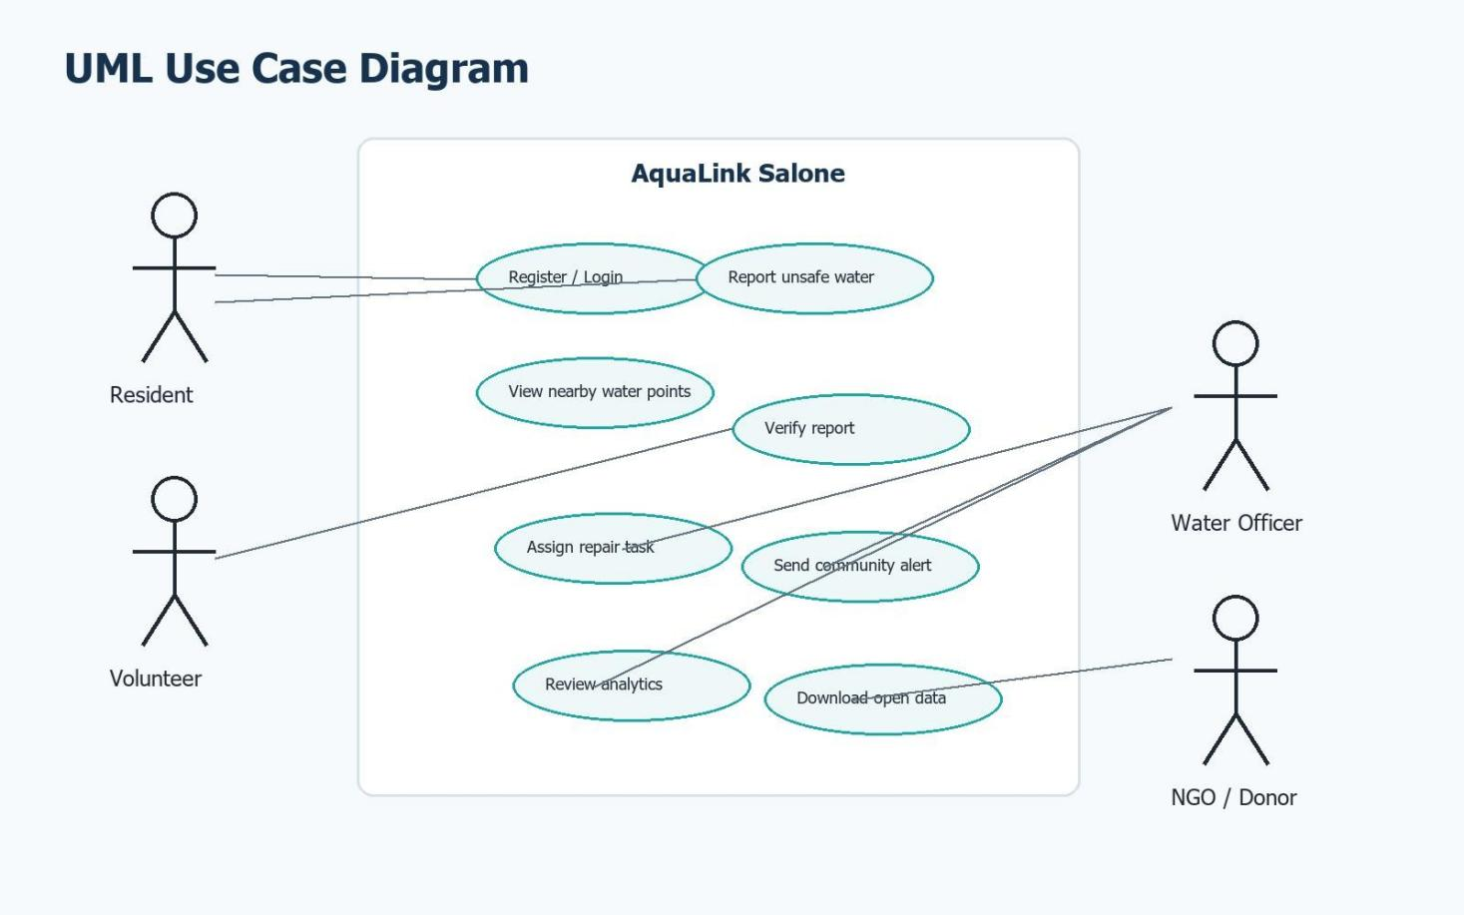
Use Case Diagram
Class Diagram
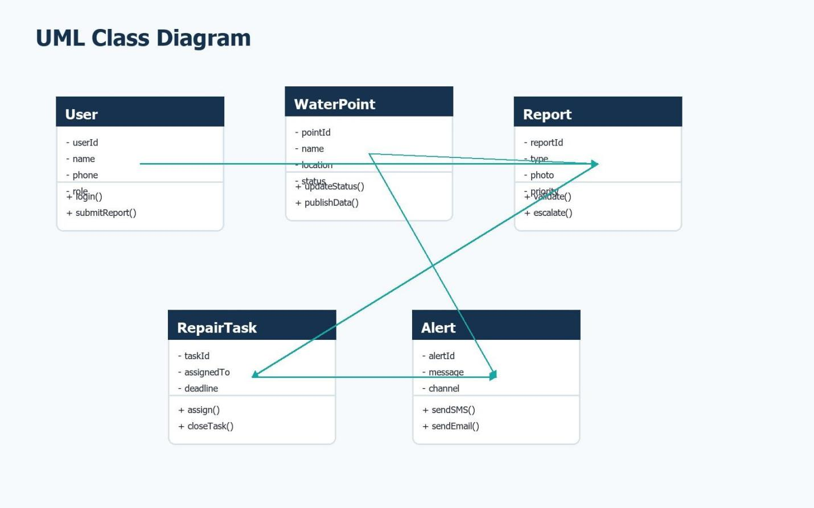

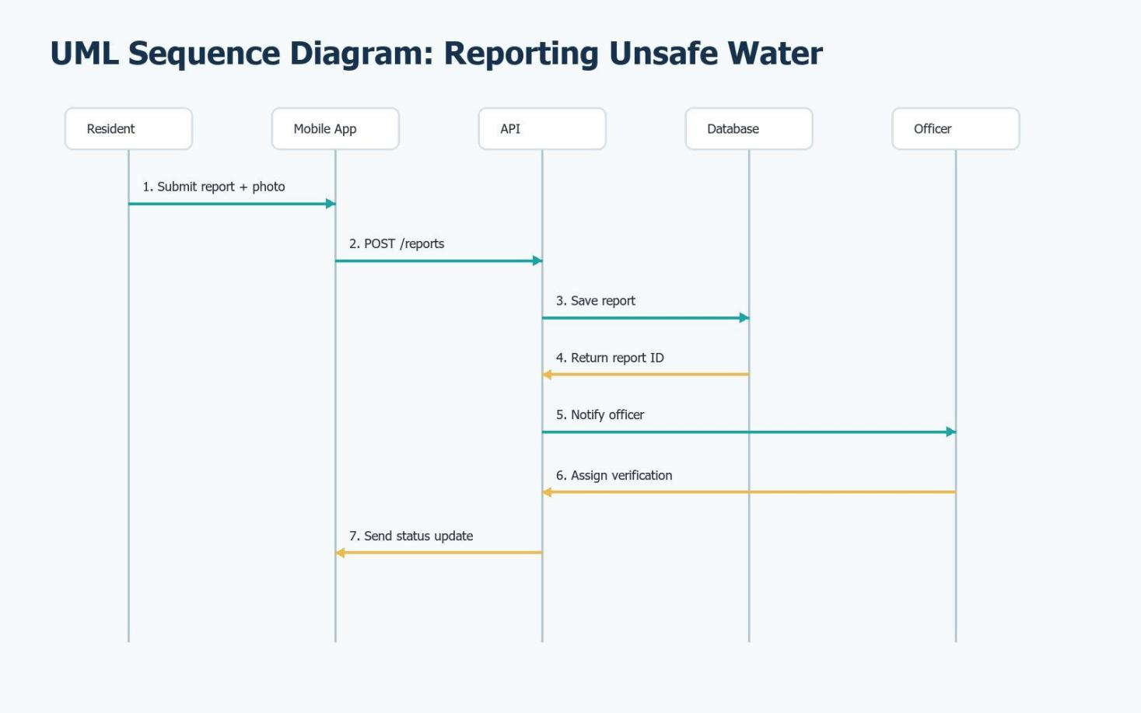
Sequence Diagram

Prototype Development and UI/UX Design
The prototype is designed as a high-fidelity Figma-ready interface. It uses consistent navigation, strong color meaning, readable cards, and simple citizen-friendly workflows. The ten key screens are listed below and included as image assets.

Screen | Purpose
1. Login | Secure entry for residents, volunteers and officers.
2. Community Home | Summary of nearby safe water points, alerts and quick actions.
3. Report Issue | Form for submitting unsafe water, broken pump or no-water reports.
4. Water Point Map | GIS map with colored status indicators.
5. Water Point Profile | Detailed status, test results, repair history and community notes.
6. Alerts | Community notices prepared for app and SMS delivery.
7. Volunteer Tasks | Field verification checklist for trusted volunteers.
8. Admin Dashboard | Officer workspace for prioritizing reports and repairs.
9. Analytics | Charts showing trends, repair time and SDG 6 indicators.
10. Water Safety Tips | Simple education content for households and schools.

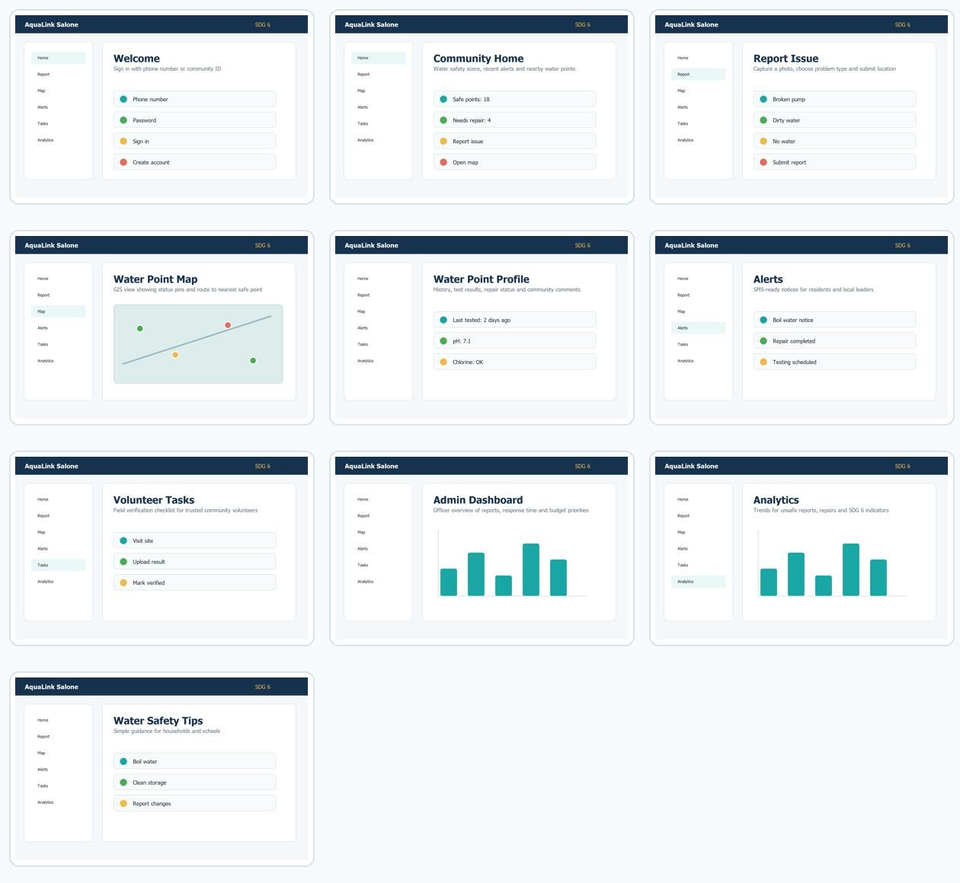

Git and GitHub Integration
- Repository name: aqualink-salone-dpg
- Suggested folders: /report, /diagrams, /prototype, /docs, /src, /tests
- Upload the final report PDF, DOCX, all diagram images, prototype screens, README and LICENSE.
- Use clear commits such as: initial project structure, add UML diagrams, add prototype screens, complete final report.
- Collaborators can be added through GitHub repository Settings > Collaborators.

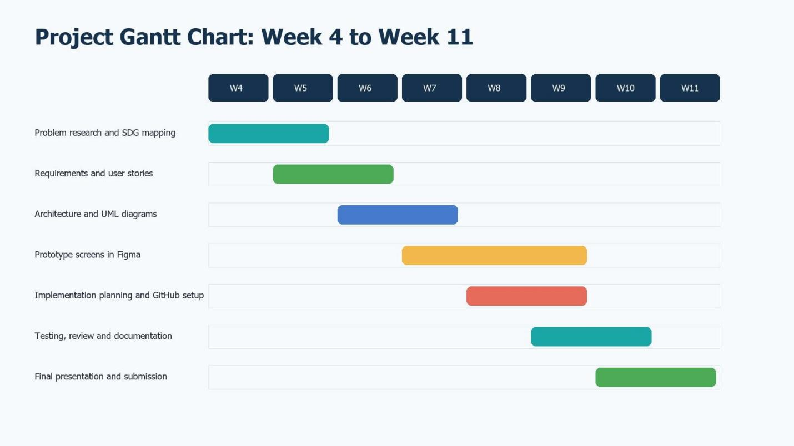
Project Plan
Activity | Duration | Predecessor
A. Research community water problem | 1 week | -
B. Define requirements | 1 week | A
C. Confirm SDG alignment and license | 1 week | A
D. Create architecture | 1 week | B
E. Draw UML diagrams | 1 week | C
F. Design prototype screens | 2 weeks | D, E
G. Create GitHub repository | 1 week | F
H. Complete report and presentation | 1 week | F
I. Final review and submission | 1 week | G, H

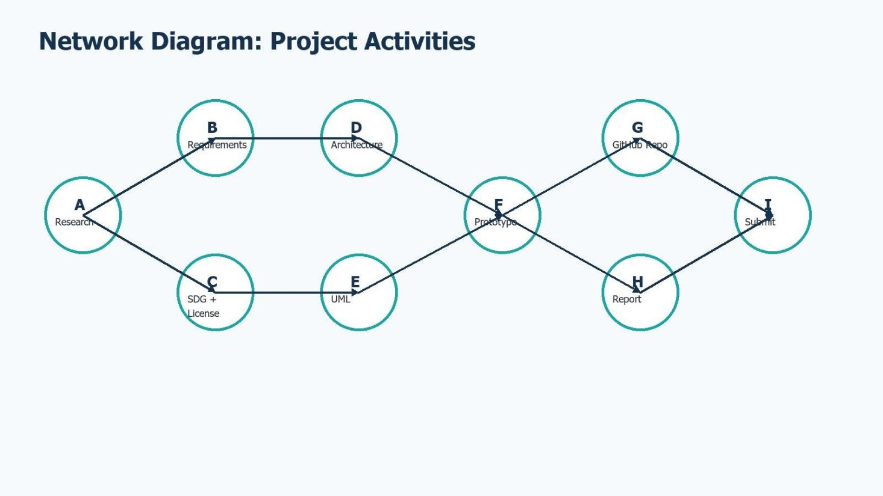

License, Design Quality and SDG Relevance
The recommended license is MIT because the system is intended as a Digital Public Good: it allows others to use, copy, modify and redistribute the software with attribution. External resources should be credited in the README. The diagrams and prototype assets in this package are original generated assets for this academic submission.
Design quality is supported by clear navigation, repeated layout patterns, accessible color meanings, short labels and user-friendly flows for both low-literacy and officer users. The project remains SDG-focused by measuring water point safety, repair response time and community alert coverage.

Conclusion
AquaLink Salone demonstrates how software engineering principles can be applied to a real public problem. The design uses an Agile SDLC, modular architecture, UML models, a 10-screen prototype, project planning diagrams, GitHub integration guidance, an open license and clear SDG relevance. The result is a practical Digital Public Good concept that can improve community reporting, repair coordination and access to safe water information.

